Lab 3 Report: Building a Cities API with Django and PostGIS
Student Name: Zhi Lin Tan
Student ID: D22127032
In this lab, I expanded the containerized GeoDjango application developed in Week 2 by building a comprehensive, RESTful spatial API using Django REST Framework (DRF) and PostGIS.
In the key achievements, designed and implemented a ‘City’ model featuring geospatial coordinates, population categorization and administrative flags. Also in this lab I implemented multiple API views and serializers providing standard JSON as well as GeoJson responses. Thirdly, I developed spatial filtering endpoints allowing radius-based queries leveraging PostGIS spatial distance calculations. Also Integrated ‘drf-spectacular’ to automatically generate OpenAPI 3.0 schemas and an interactive Swagger UI.

Challenges
The issue I face is the starter configuration references ‘map’, but my week 1 was created under the folder name ‘mapping’. This caused it cant find the module named ‘maps’ during app initialization and test running.
The second challenge is after spinning up the new week3 containers, the previous pgAdmin state clean and required reconnection. Attempts to connect via ‘localhost’ failed. So, I utilized Docker’s internal DNS bridge by setting the database host name to the compose service name ‘db’, enabling successful connection to the ‘hello_map_dublin’ database.

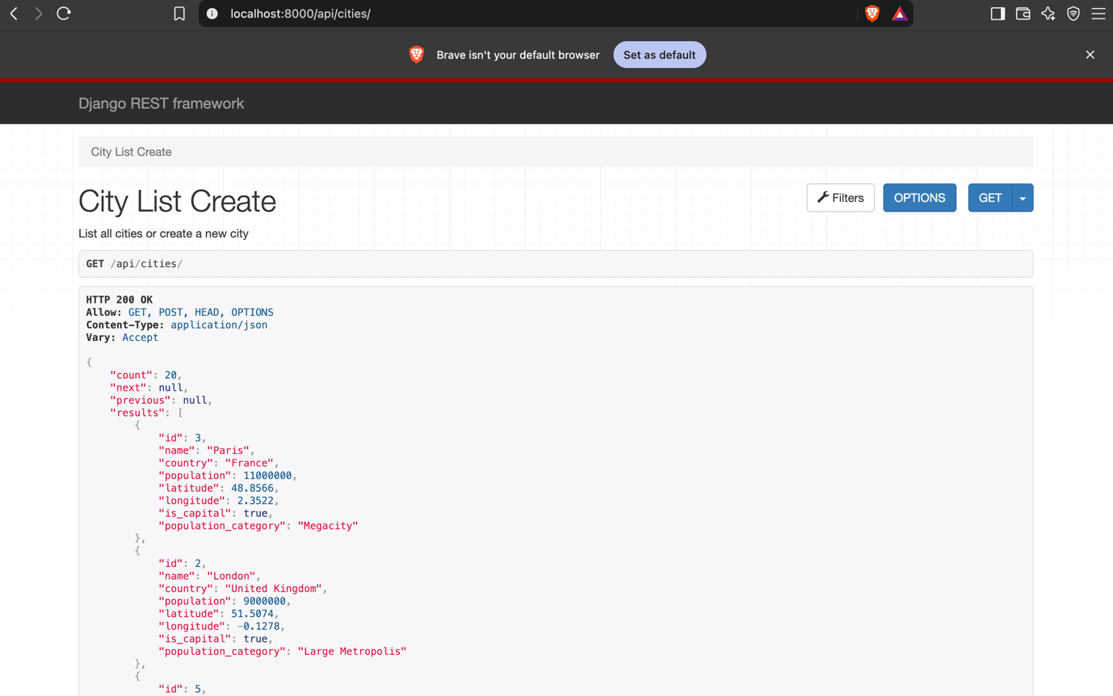
http://localhost:8000/api/cities/

This will show the city detail (http://localhost:8000/api/cities/1/)
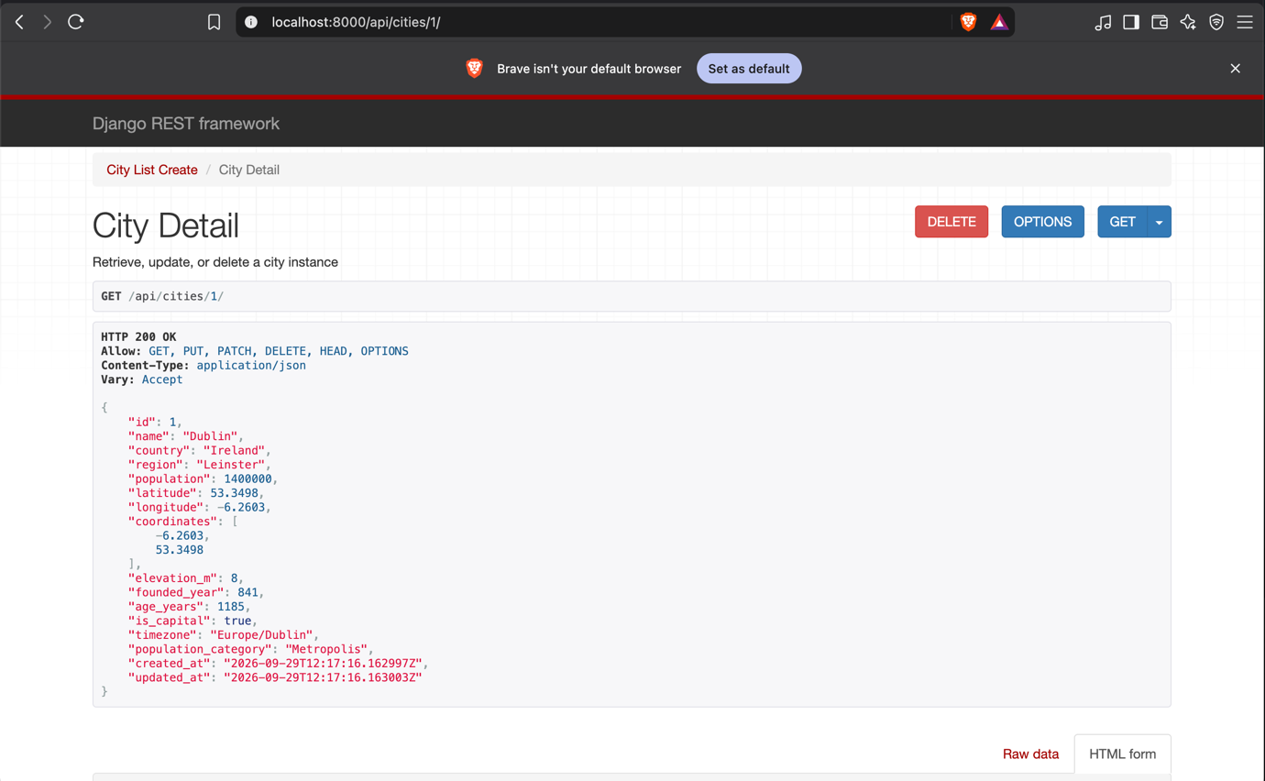

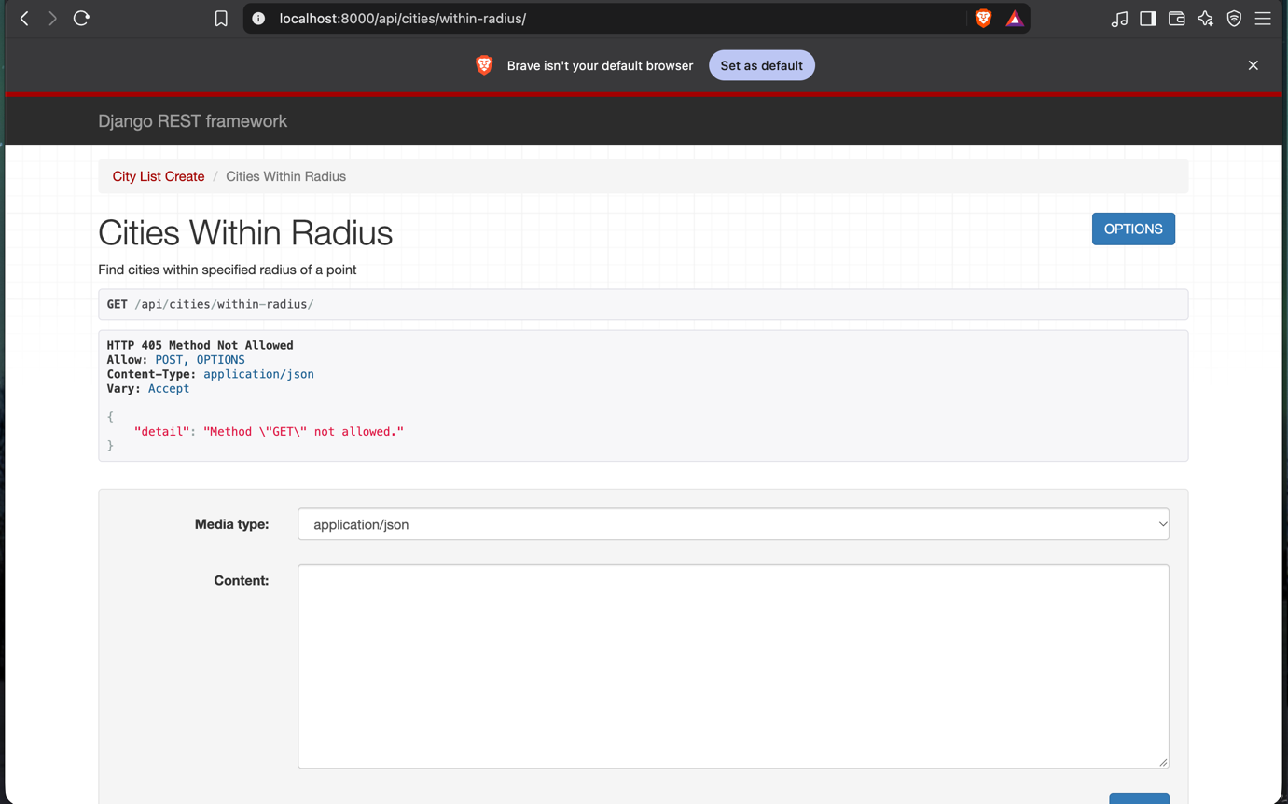
http://localhost:8000/api/cities/within-radius/
Note: Direct browser navigation issues a GET request, resulting in HTTP 405 Method Not Allowed as designed. This endpoint strictly accepts POST requests containing payload parameters (`latitude`, `longitude`, `radius_km`) to perform spatial filtering via PostGIS.
